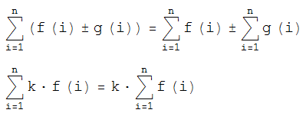



k n



1/2 n (1+n)



1/6 n (1+n) (1+2 n)



1/4 n2 (1+n)2



1/30 n (1+n) (1+2 n) (-1+3 n+3 n2)



1/12 n2 (1+n)2 (-1+2 n+2 n2)



1/42 n (1+n) (1+2 n) (1-3 n+6 n3+3 n4)



1/24 n2 (1+n)2 (2-4 n-n2+6 n3+3 n4)



1/90 n (1+n) (1+2 n) (-3+9 n-n2-15 n3+5 n4+15 n5+5 n6)



1/20 n2 (1+n)2 (-1+n+n2) (3-3 n-n2+4 n3+2 n4)



1/66 n (1+n) (1+2 n) (-1+n+n2) (-5+10 n+3 n2-11 n3+2 n4+9 n5+3 n6)



